- Find the most repeated number (build list of range(1,9) and count each one repeated number ) this case = 8
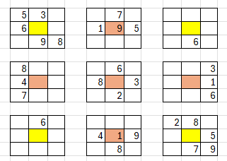
- Build one layer for this number only number (in this case =8)
Block all cells that CAN NOT be this number with gray
If one box has number 8 then all the empty cells in this box will be colored gray
Any empty cell in each row and in column as this number will be colored gray as well
First gray empty cell in each box then gray each row and each column empty cells that intersect on this cell that have this number
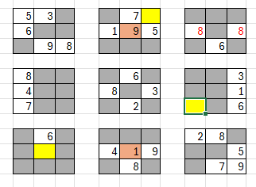
- Check any box if it has only one empty cell that its color is not gray, color this empty cell yellow
- Check each box for if the box has only one cell empty then set this cell with the layer number, we used to build this layer (in the case set number 8 in all yellow cells) and if any box have more than one empty cell not grayed fill it by layer number in this case is number 8 in the top right box in 8 in red
- After filling the yellow cells loop again on all boxes, (do again step 3 and 4) check any box that has more than one empty cell still not grayed out, and now based on the refilled yellow cell gray out any cell than can not be the layer number
- Break when you have set all the cells and no empty cells any more
- Build new sudoku with the new founded cells for this layer
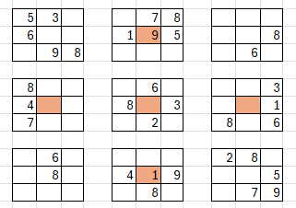
- Go to the next most repeated number and build it layer and do the same
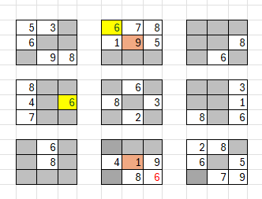
- Regenerate the new sudoku base using the last layer number
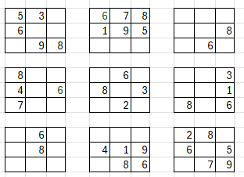
Repeat all these steps again until no change in the base set
- Check any column or row that has only one cell empty set it by the missing number in its column or in its row

